“BALI, INDONESIA TOUR”
(5Night / 6Days)

Experience the perfect blend of adventure, culture, and breathtaking natural beauty with this 6 Days / 5 Nights Bali Tour Package. Begin your journey by relaxing on Bali's stunning beaches and enjoy an exciting Banana Boat ride at Tanjung Benoa. Witness the spectacular Kecak Dance Performance against the backdrop of the majestic Uluwatu Temple at sunset. Explore the picturesque island of Nusa Penida, famous for its dramatic cliffs, crystal-clear waters, and iconic viewpoints like Kelingking Beach and Broken Beach. Visit the serene Ulun Danu Temple, the magnificent Tanah Lot Temple, and the scenic Kintamani region overlooking Mount Batur. Experience the thrill of the famous Aloha Ubud Swing, stroll through the charming Ubud Palace, and shop for local handicrafts at the vibrant Ubud Art Market. Throughout the journey, enjoy delicious dinners at Indian restaurants, ensuring a comfortable and memorable holiday in the Island of Gods.
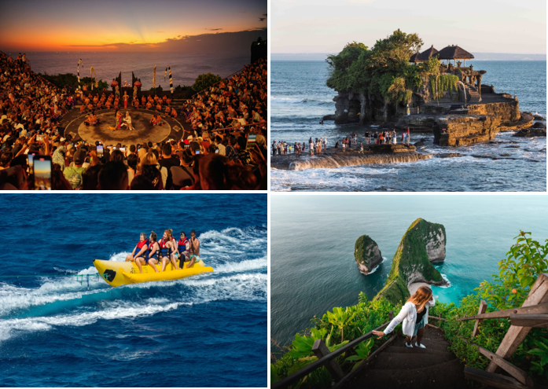
We wish you a happy, safe and unforgettable journey with us
DAY WISE ITINERARY
Days | Date | Program
Day 1 | 30-Sep-2026 | Arrival at Airport – Transfer into hotel – Dinner at Indian Restaurant
Day 2 | 01-Oct-2026 | Water Sport Activity (1x Banana Boat) at Tanjung Benoa Beach – Visit Uluwatu Temple – Kecak Dance Performance – Dinner at Indian Restaurant
Day 3 | 02-Oct-2026 | Nusa Penida West Island Tour includes return fast boat (visit Angel’s Bilabong, Crystal Bay, Kelingking Beach, Broken Beach) include simple local lunch – Dinner at Indian Restaurant
Day 4 | 03-Oct-2026 | Ulun Danu Temple Bedugul – Tanah Lot Temple – Dinner at Indian Restaurant
Day 5 | 04-Oct-2026 | Kintamani Area (Mt.Batur Volcano view from the distance) – Tegalalang Rice Terrace – Aloha Ubud Swing Active Package (Inclusions: 1x Adrenaline Swing, 1x Single Swing, 1x Tandem Swing, 1x Libra Swing, 1x Bed Swing, Photostop: 1x Cute Chicken Nest, 1x Cute Bird Nest, 1x Swan Love) – Ubud Palace – Ubud Art Market – Dinner at Indian Restaurant
Day 6 | 05-Oct-2026 | Transfer out to airport

Tour ends with unforgettable memories
Hotel & Price details:
Option 1 | Hotel Name /Night | Star | Room Type | Price per Pax (USD)  Twin/Triple Share
A | GRAND ZURI / 05Nights | 4⭐ | Superior Room | USD 355 /ADULT  USD 250 /CWB  USD 183 /CNB
B | BINTANG KUTA / 05 Nights | 4⭐ | Deluxe Room | USD 414/ADULT  USD 293/CWB  USD 212/CNB
Inclusion: -
- 05N stay at selected hotel based on Twin / Triple Sharing as mentioned above.
- Daily breakfast at hotels & Dinner in Resturant.
- Flower garland upon arrival
- Return airport transfer and tours by air-conditioned Vehicle on Private basis
- Meal’s arrangement as per mention on day wise itinerary
- English Speaking Driver during the tours and transfer (for 02 – 04 Pax)
- 02 Bottles of 600 ML mineral water during tour & transfers per person
- Entrance Ticket to the tourism object as per mentioned in the day wise itinerary

Exclusions: -
- International or Domestic airfare
- Visa fees (USD 35 approx. PP)
- Travel insurance
- Personal expenses
- Other activity / services are not indicated in the package inclusions above
Starting from 14 February 2024, every international tourist travelling to Bali will be required to pay RP150,000 (US$9.60) per person, contributing to the preservation of Bali’s culture and natural environment.
The official website, Love Bali, advises travellers to make payments before their arrival in Bali to facilitate a smoother travel process.

PLEASE NOTE:
- Hotel early check-in, late check-out, connecting, or adjoining rooms are subject to availability and are not guaranteed.
- No refund for unused services and no refund for your or program in the events of Natural Calamity or Disaster, poor weather conditions, civil disturbance, suspension of services related to Airlines, transportation, accommodation etc, government orders or circumstances beyond company’s control. Splitting of package is not allowed.
- Please note that local conditions prevalent at the time of travel may result in modifications to the tour contents without prior notice.
- No rooms being blocked, room is subject to availability when we make bookings.

Note: All Dollar payments to be done in accordance with current XE.com + 01 INR. 2% TCS mandatory with declaration for Intl. bookings.

